Newsletter May 2024 – II

**India Space Congress 2024**

The India Space Congress (ISC) 2024, Conference and Expo, with the theme “Space Innovation: Bridging Boundaries, Transforming Tomorrow,” " will be held from June 26 –28, 2024 at TheLalit, New Delhi.

This premier event is a catalyst for shaping the future of space technology, fostering collaboration, inspiring disruptive business models, driving investments, nurturing startups, and influencing regulatory and policy support.

To access the ISC 2024 brochure, please find the attached links: ISC 2023 Brochure:   
<https://www.indiaspacecongress.com/wp-content/uploads/2024/05/ISC-2024-Brochure-pdf-with-country-partner-and-other-partner.pdf>Join us for this valuable event by registering at: <https://www.indiaspacecongress.com/register/>

SIA-India Partnership Support for ISC 2024:

ISRO (Logo)

In-SPACe (Logo)

NITI Aayog (Logo)

NSIL (Logo)

**S**wissnex in India, Consulate General of Switzerland" **Joins ISC 2024 as Country Partner**

We are honoured to announce the "**S**wissnex in India, Consulate General of Switzerland" has joined as the “Country Partner” for ISC'24. This collaboration marks a significant milestone in fostering international cooperation and innovation in the space industry. Their active involvement will enrich the conference experience for attendees, fostering meaningful connections and facilitating knowledge exchange.

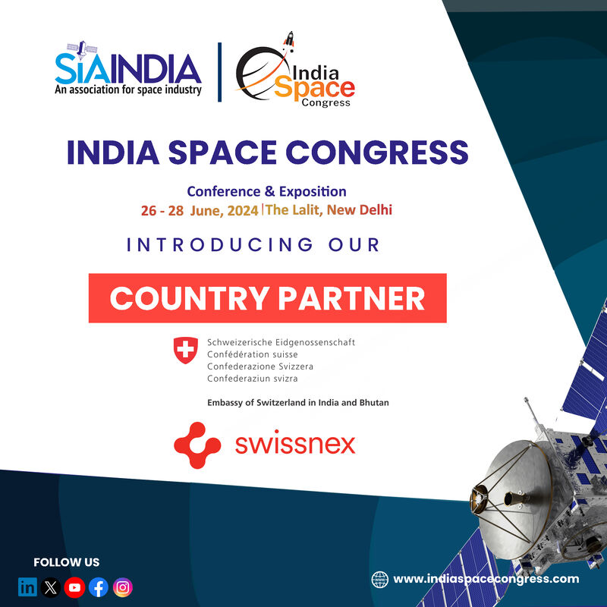

ISC 2024 Speakers Announcement:

Speakers with designation (photos)

**Our Partners**

Knowledge partner (Logo)

Exposition Partner (Logo)

Media Partner (Logo)

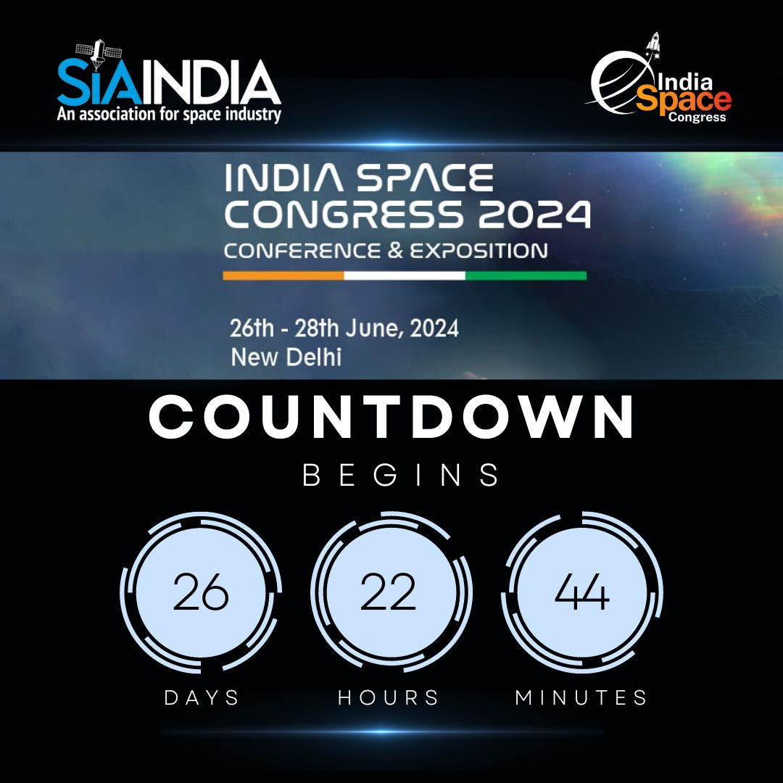

Website: www.indiaspacecongress.com

QR.

SIA-India's India Space Congress 2024 Captivates Global Attention

Top news outlets like The Week, NDTV Profit, IBC24, Jagran, The Print, and The Indian Community have buzzed about the ISC 2024 highlighting its significance and the excitement surrounding the landmark event in India's space sector.   
Financial Express: <https://www.financialexpress.com/life/science-india-space-congress-2024-pioneering-the-future-of-space-exploration-3487427/>

Indian Express: <https://indianexpress.com/article/technology/science/india-space-congress-to-be-held-in-june-9328994/>

https://www.businesstoday.in/visualstories/news/new-delhi-to-host-india-space-congress-2024-in-june-135972-15-05-2024

The Week: <https://lnkd.in/gKbSnXca>NDTV Profit: <https://lnkd.in/gebGkZzB>IBC24: <https://lnkd.in/gXuPTbrf>Jagran: <https://lnkd.in/gJV6rJCH>The Print (Hindi): <https://lnkd.in/gtrH_QgE>The Indian Community: <https://lnkd.in/g3bYtqBF>

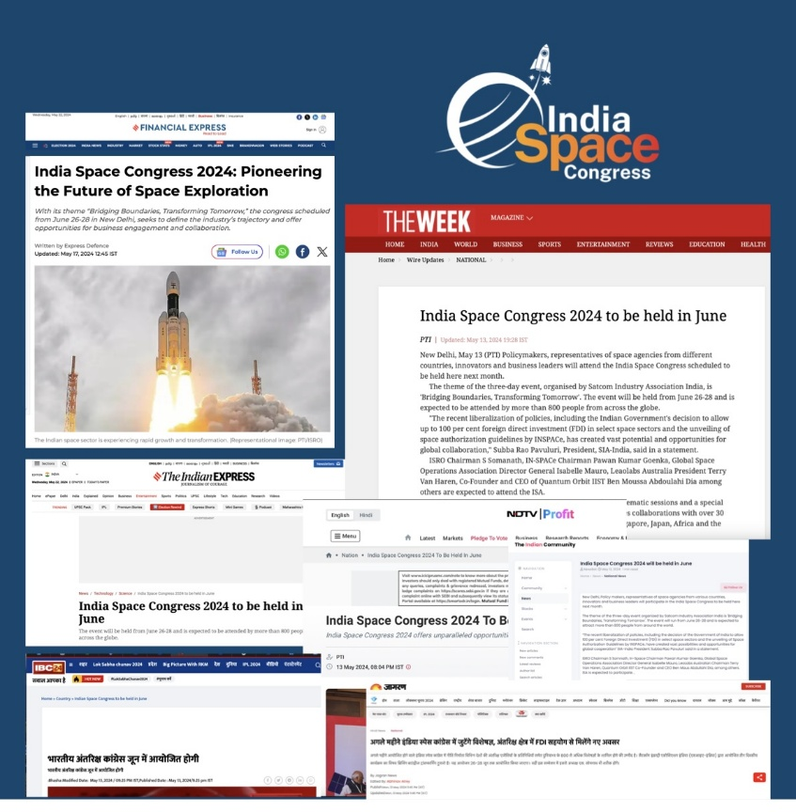

**Policy and Regulatory**

India's Quantum Leap: National Mission and SIA-India's Perspective

India launched the National Quantum Mission India with a substantial budget allocation of INR 8,000 crore (USD 1.2 billion) aimed at advancing quantum technologies. This ambitious initiative is expected to propel India to the forefront of quantum computing and communication research, with targeted outcomes including the development of 50 qubit quantum computers by 2026. The mission's impact spans various sectors, including cryptography, where it promises unbreakable encryption methods; materials science, where it aids in the discovery of new materials; and secure communications, enhancing data security for both civilian and military applications.

SIA-India views this mission as transformative, enhancing India's secure communication capabilities. With unprecedented data security and reliability, it will significantly advance satcom through unbreakable encryption, improved operational efficiency, and strategic benefits, positioning India as a leader in global satellite communications.

Refer Document: <https://pib.gov.in/PressReleaseIframePage.aspx?PRID=2011633>

**Technology and Innovation**

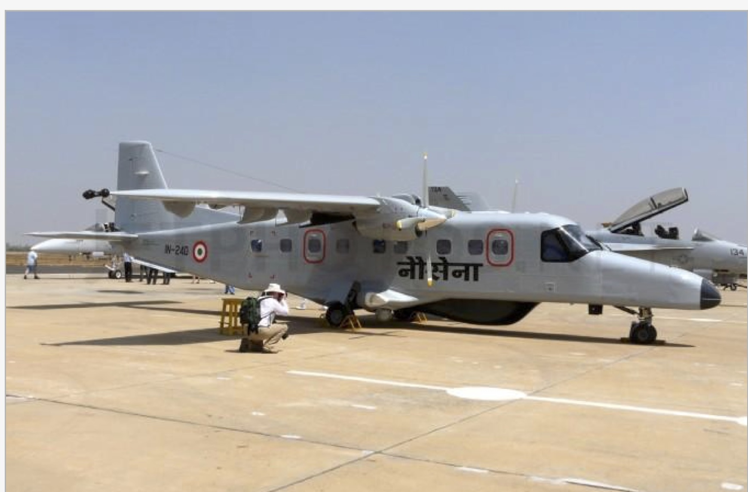

DRDO Develops High-Resolution Radar for Enhanced Dornier Surveillance

India’s Defence Research and Development Organisation (DRDO) is advancing aerial surveillance capabilities through the development of a high-resolution X-band Synthetic Aperture Radar (SAR) for Dornier-228 aircraft, produced under license by Hindustan Aeronautics Limited (HAL). This radar employs microwave technology to provide real-time intelligence, operating efficiently in all weather conditions and during both day and night. The SAR system can accurately detect stationary and moving targets and generate detailed terrain maps, which are crucial for mission planning and target engagement. Weighing approximately 230 kg, the system includes an antenna, data processing units, cooling systems, and GPS for precise positioning. Integrating this radar into the Dornier-228 not only allows for performance evaluation in airborne environments but also facilitates the potential retrofitting of other Dornier aircraft with this advanced SAR technology.

To read more: <https://idrw.org/drdo-develops-high-resolution-radar-for-enhanced-dornier-surveillance/>

## Agnikul launches World’s First Rocket with Fully 3D Printed Engine

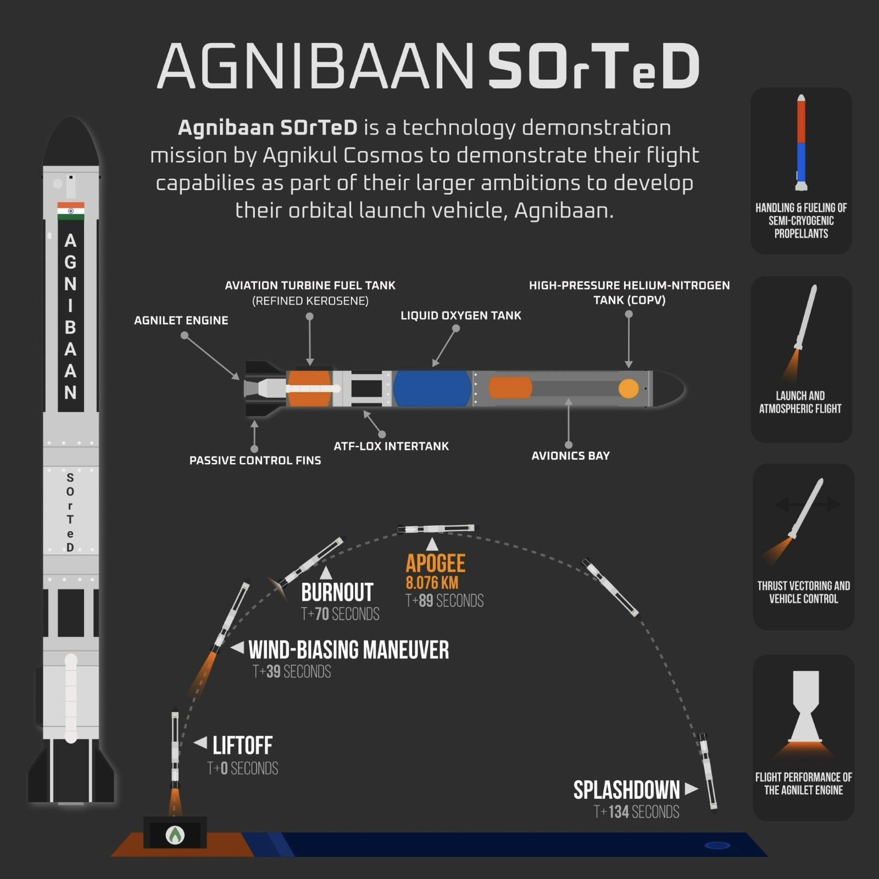

Agnikul Cosmos, a Chennai-based aerospace startup is set to launch its maiden sub-orbital rocket, Agnibaan Sub Orbital Technology Demonstrator (SOrTeD). The Agnibaan rocket, capable of carrying a payload of up to 300 kg into a 700 km orbit, features a semi-cryogenic engine using sub-cooled liquid oxygen and aviation turbine fuel. This test validates the avionics chain's capability in controlling the propulsion system and runs the same Automated Launch Sequence (ALS) expected during the actual launch. This milestone marks a significant achievement, which has been working diligently to make its mark in the space industry. The upcoming launch demonstrates Agnikul's resilience and dedication to advancing India's private space capabilities and continues to push the boundaries of aerospace innovation.

To read more: <https://pib.gov.in/PressReleasePage.aspx?PRID=2022161>

# **Bengaluru startup that makes silicon replacement for chips to scale production**

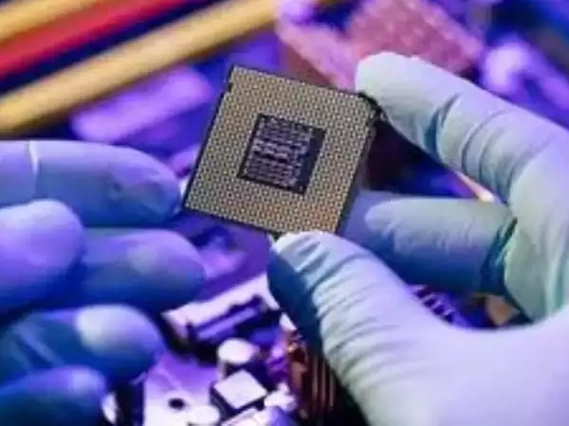

NoPo Nanotechnologies, based in Bengaluru, is scaling up its production capacity to meet the growing demand for its advanced material, single-walled carbon nanotubes (SWCNTs). With applications ranging from EV battery manufacturing to semiconductor design, the company is attracting interest from chipmakers in Taiwan and Japan. NoPo's latest funding of $3 million from Axilor Ventures’ Micelio Funds and Inflexor Ventures will facilitate the establishment of a new plant in Bengaluru or nearby Hosur. It’s unique ability to produce single chiral SWCNTs with tight band gap control positions it as a key player in the nanotechnology industry, with potential applications in advanced semiconductor designs and high-energy-density batteries.

To read more: <https://m.economictimes.com/magazines/panache/people/et-circle-the-private-equity-playbook-with-manish-kejriwaltrust-mentorship-and-intellectual-honesty-as-pivotal-pillars/amp_articleshow/110211288.cms?articleno=2>

**SIA-India Update**

**SIA-India participated in US-India Commercial Space Cooperation Conference**

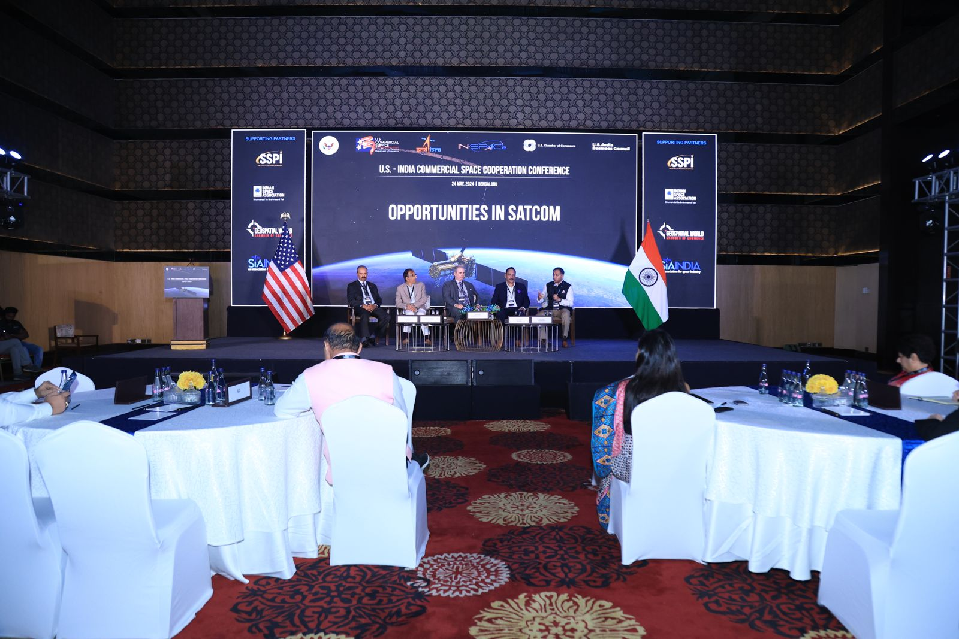

Our Director General, Mr Anil Prakash along with our Board Member Mr Govindrajan, President of Aniara Communications, recently participated in the U.S. Foreign Commercial Service (FCS) and the United States-India Business Council (USIBC) event, "U.S. - India Commercial Space Conference: Unlocking Opportunities for U.S. & Indian Space Startups," held on 24 May 2024 at JW Marriott, Bengaluru, India. During a panel discussion, he highlighted that welcoming foreign companies to invest in and collaborate within India's space sector positions India as a pivotal hub for global space activities. He also provided valuable insights into the recent reforms shaping India's policy landscape, including the India Space Policy 2023, Telecommunication Act 2023, Standardization of Space Industry, FDI Liberalization Policy 2024, IN-SPACe Norms, Guidelines and Procedures document, and the National Deep Tech Startup Policy 2024.

**SIA-India celebrates Hungarian Defence Forces Day!**

SIA-India proudly acknowledged and celebrated the dedication and service of the Hungarian Defence Forces. Anil Prakash, Director General of SIA India, and Anbalagan K, Deputy Director of International Cooperation, extended their heartfelt wishes to H E Mr. István Szabó, Ambassador of Hungary, and Lieutenant Colonel László Kővári, Defence, Military, and Air Attaché, on the occasion of Hungarian Defence Forces Day. This event marked a moment of appreciation and recognition for the contributions of the Hungarian Defence Forces.

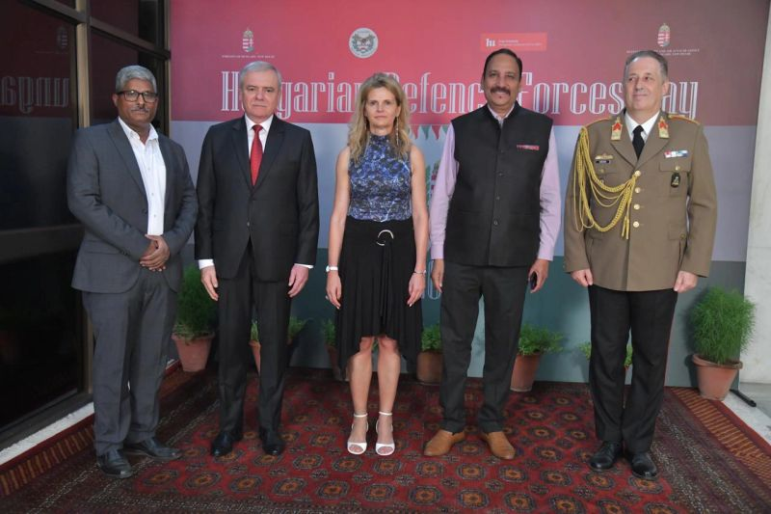

SIA-India and KOTRA Discuss Space Industry Cooperation

SIA-India recently held an important discussion with Mr Ohsung Kwon, the Deputy Managing Director of KOTRA (Korea Trade-Investment Promotion Agency, about cooperation in the space industry between India and the Republic of Korea. This meeting marked a significant step in fostering collaboration between the two countries, highlighting the potential for shared advancements and partnerships in space exploration and technology. The conversation set the stage for future cooperation, aiming to drive innovation and mutual benefits in the space sector.

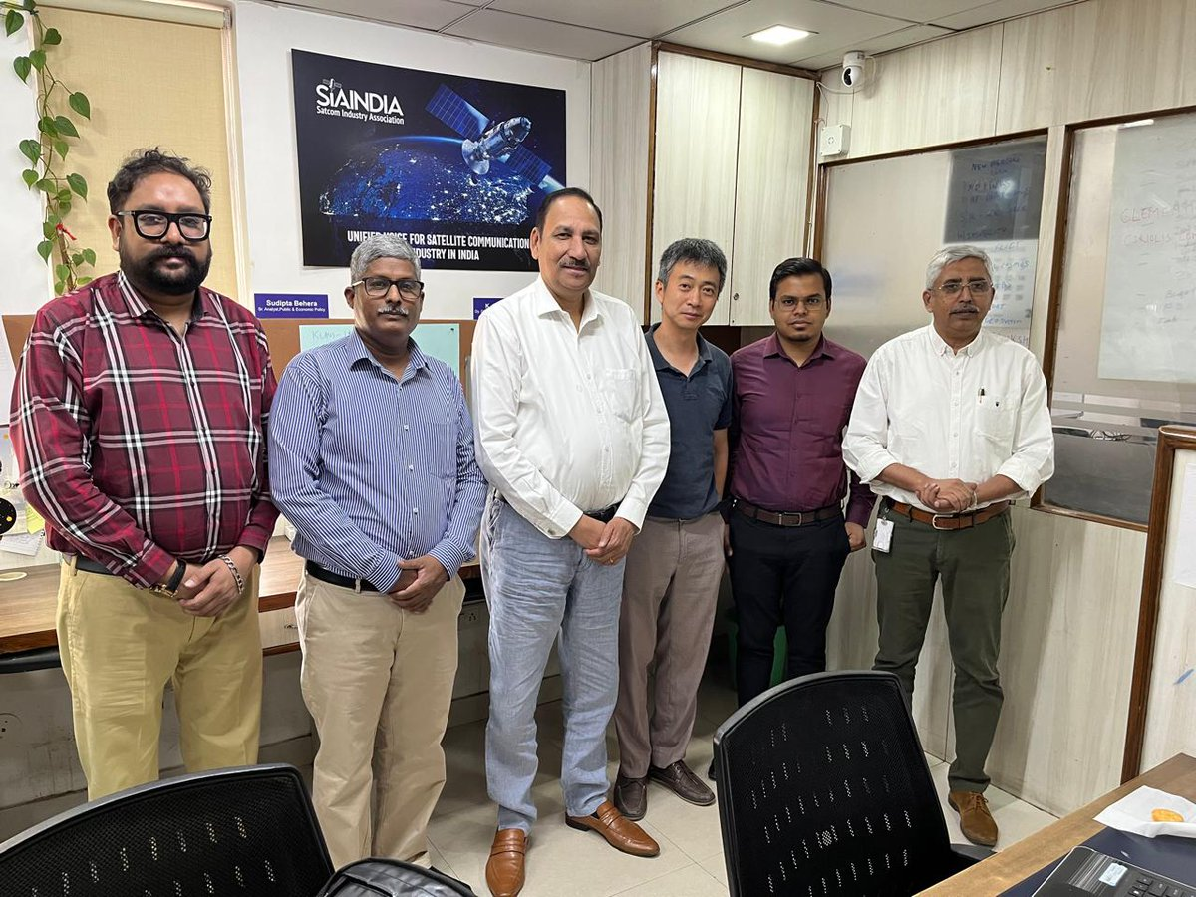

SIA-India Initiates Groundbreaking Survey to Establish Comprehensive Space Sector Database

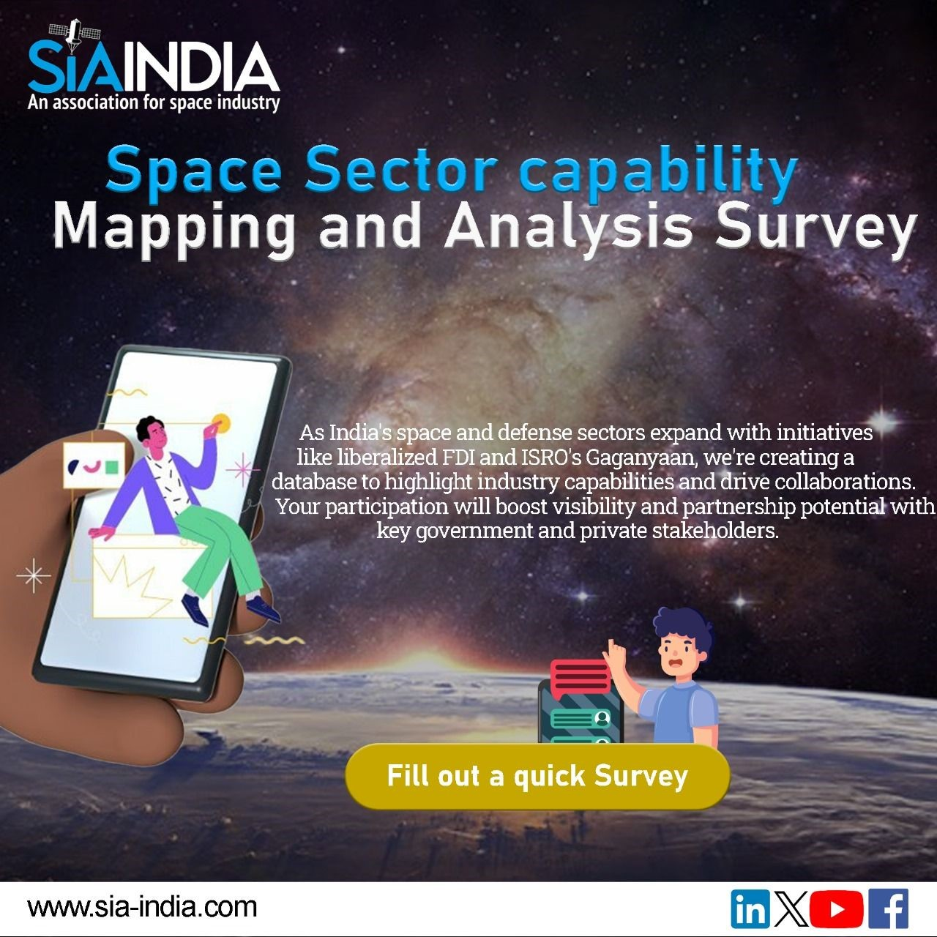

SIA-India has taken an initiative to enlist all the space-related companies in **One Stop Shop portal,** being the first private entity to do so. It has launched Space Sector Capability Mapping and Analysis survey to construct a searchable database for space sector organizations, aiming to boost collaboration with government and private stakeholders. Participation is crucial for creating this resource and fostering innovation. The database will facilitate cooperation, streamline communication, and drive industry growth. Every submission shapes this collective effort. Stakeholders are urged to contribute to propel shared goals forward.

Click the link to participate and shape the future of the space sector: <https://forms.office.com/r/eNAyWGgkWF>

SIA-India's Stellar Nexus Conversation: Latest Publications Update

In the latest addition to the stellar nexus conversation section is Mr Abhishek Malhotra’s article on "**Navigating Liability Through Risks in the Space Sector,**". The article explores India's growing global presence in space, discussing recent regulatory advancements, including the Notified Guidelines by IN-SPACe. Emphasising responsible governance and liability management, the piece highlights the importance of third-party liability insurance and clarity regarding obligations for Indian and non-Indian entities, crucial for sustaining a vibrant space ecosystem amidst increased private sector participation.

**Read more:** <https://www.sia-india.com/corner/navigating-liabilitys-through-the-risks-in-the-space-sector/>

SIA-India in News

# Space TRIAD for Deep Battles

(photo)

Lt. Gen. PJS Pannu, Senior Advisor to SIA-India, highlights space's pivotal role in warfare, stressing the integration of observation, navigation, and communication for precise targeting and strategic advantage. Emphasizing the importance of Positioning, Navigation, and Timing (PNT) systems, he underscores their role in modern military operations. ISC-24, organized by SIA-India, will serve as a platform to address these critical issues and bring together stakeholders to advance defense space technologies. Through collaborative efforts at ISC-24, advancements in space assets and strategies will enhance national defense capabilities and promote effective resource utilization in contested environments.

**To read more** <https://www.financialexpress.com/business/defence/spacenbsptriadnbspfornbspdeepnbspbattles/3497341/>

**Member’s Column**

# Space start-up Galaxeye sends up a SAR on NAL’s high-altitude platform

Galaxeye, A Bengaluru-based space firm is paving the way for all-weather, all-time imaging by successfully testing Synthetic Aperture Radar (SAR) on a High-Altitude Pseudo-Satellite (HAPS) platform. This achievement marks a significant advancement in remote sensing technology, offering enhanced imaging capabilities regardless of weather conditions or time of day. The successful test highlights the firm's innovative approach to improving data collection from the stratosphere.

To Know More: <https://theprint.in/science/paving-way-for-all-weather-all-time-imaging-bengaluru-space-firm-tests-sar-on-haps-platform/2095312/>

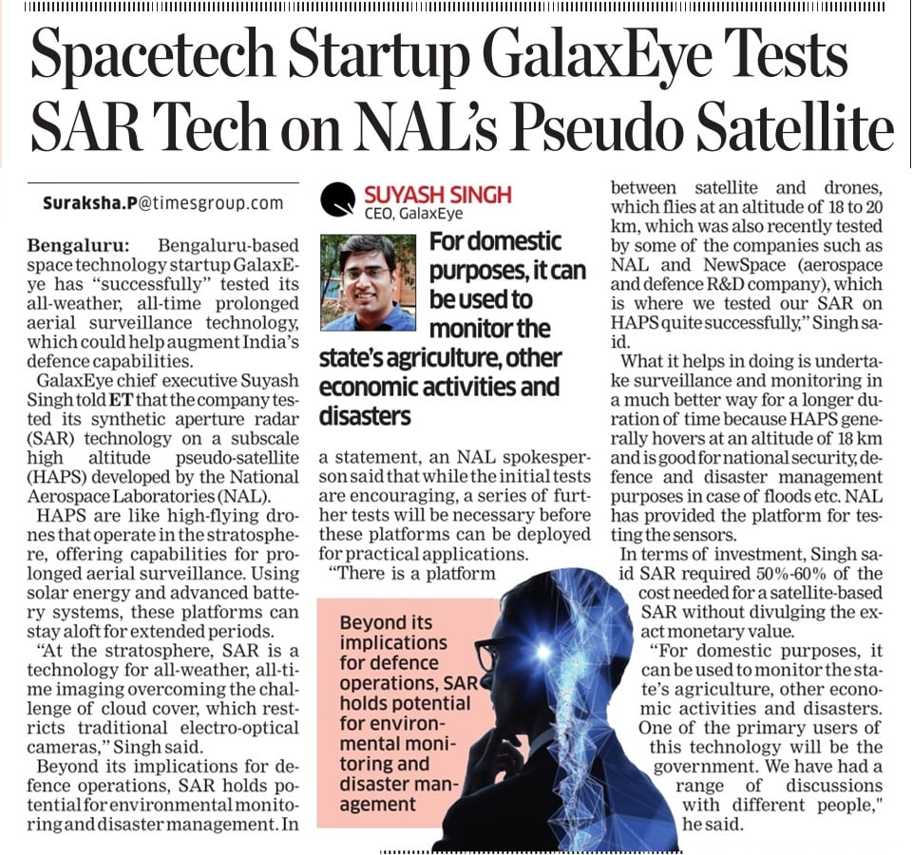

# GalaxEye signs MoU with IN-SPACe to Advance Earth Observation Technologies

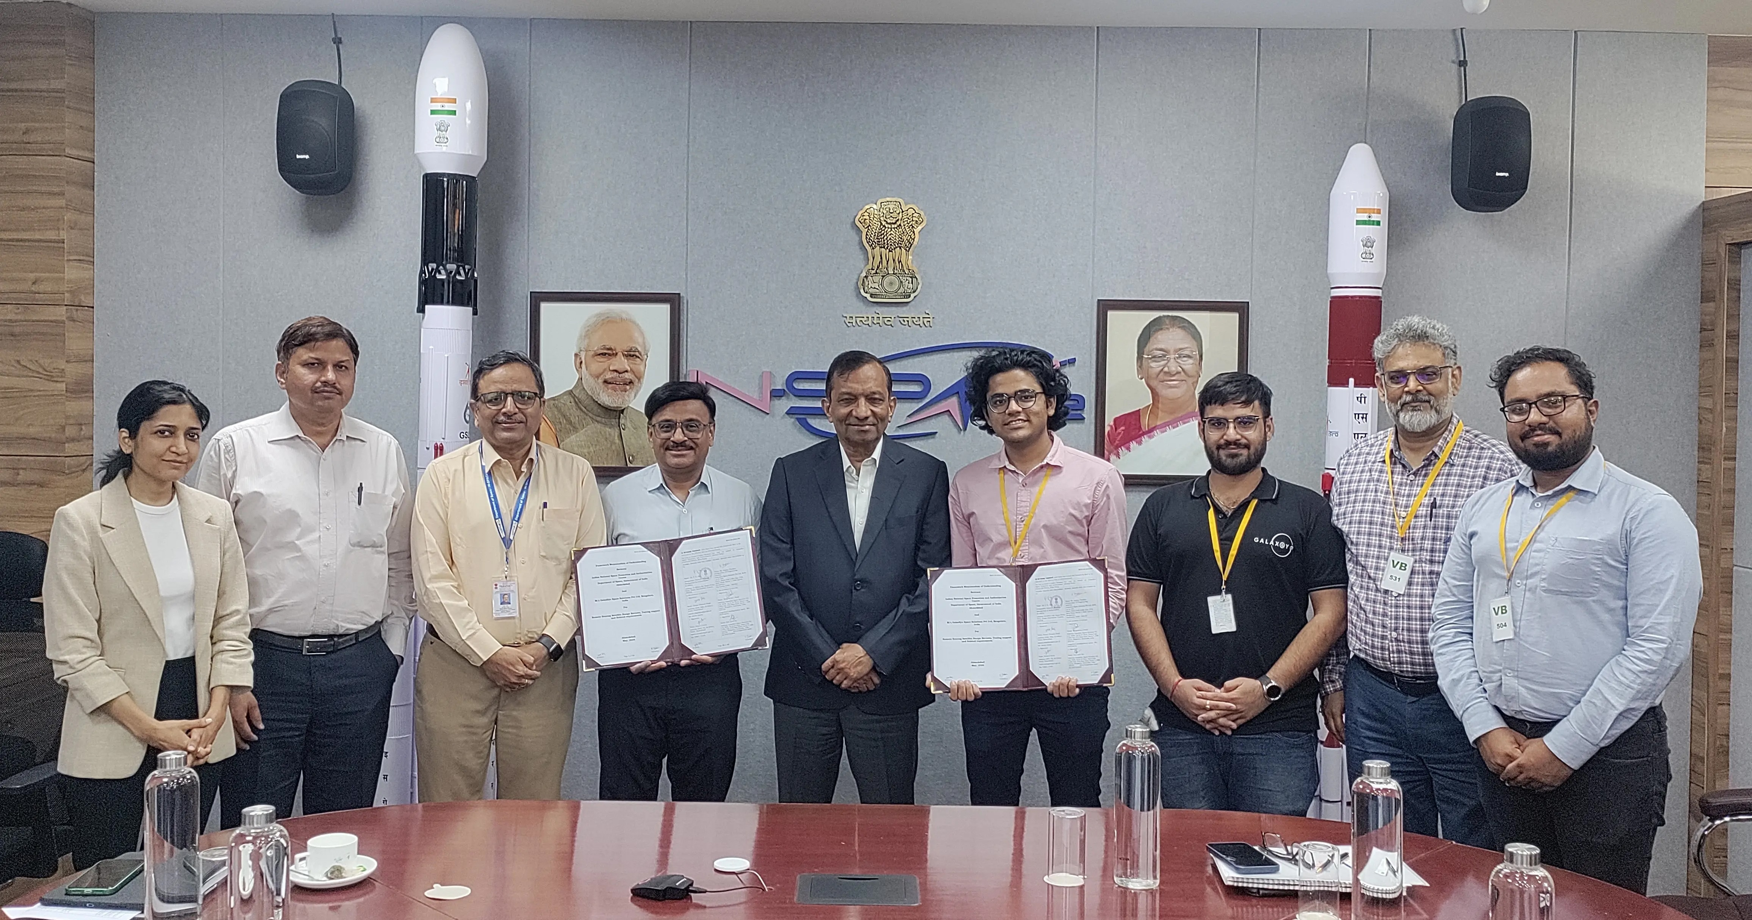

GalaxEye, a pioneering space-tech startup focused on earth observation satellites, has signed a significant Memorandum of Understanding (MoU) with the Indian National Space Promotion and Authorization Centre (IN-SPACe). The MoU, signed in Ahmedabad, was formalised in the presence of key representatives from both organisations, including Dr. Pawan Goenka (Chairman), Dr. PK Jain (Director), Dr. Rajeev Jyoti (Director), and Pranav Singh (Deputy Director) from IN-SPACe, alongside Kishan Thakkar (VP Engineering), Dr. Deb Jyoti Pal (Senior Vice President), and Raageshver Sood (Lead Spacecraft Systems Engineer) from GalaxEye. This collaboration positions GalaxEye as the first beneficiary of IN-SPACe’s premier coworking and testing space in Ahmedabad and facilitates access to ISRO’s cutting-edge laboratories and testing facilities. GalaxEye, known for building India's first indigenous drone with Synthetic Aperture Radar (SAR), is now developing the Drishti Mission, India's first private constellation of Earth Observation satellites. This initiative supports the 'Make in India for the World' campaign, solidifying India’s leadership in global space technology and its applications for societal benefit.

**Become a member**

(POSTER)

**DG Connect**

“India's trajectory is poised for remarkable advancements. With a pragmatic approach and a steadfast commitment to innovation, India is positioning itself as a frontrunner in harnessing quantum technologies for practical solutions. With futuristic goals in mind, India envisions a future where quantum technologies drive transformative changes across various sectors, enhancing data security, accelerating scientific discoveries, and fueling economic growth.”

Mr. Anil Prakash

Director General, SIA-India

**Other National and International News**

* 1. Space regulator IN-SPACe conferred with global leadership award

Read more at: <https://www.linkedin.com/posts/satcom-industry-association_space-regulator-in-space-conferred-with-global-activity-7197158054910435328-oQOW?utm_source=share&utm_medium=member_android>

* 1. Launch of the National Space Operations Centre (NSpOC)  
     Read more at: <https://economictimes.indiatimes.com/news/science/isro-releases-issar-2023-report-on-vulnerability-of-space-assets-to-collisions/articleshow/109700558.cms>
  2. [Researchers uncover attack to ‘decloak’ VPN traffic](https://www.telecomstechnews.com/news/2024/may/07/researchers-uncover-attack-decloak-vpn-traffic/)

To know more: <https://www.telecomstechnews.com/news/2024/may/07/researchers-uncover-attack-decloak-vpn-traffic/>

* 1. Space regulator IN-SPACe conferred with global leadership award   
       
     Read more at: <https://telecom.economictimes.indiatimes.com/news/portal-in-portal/satcom/space-regulator-in-space-conferred-with-global-leadership-award/110162442?utm_source=whatsapp_web&utm_medium=social&utm_campaign=socialsharebuttons>

**Events**

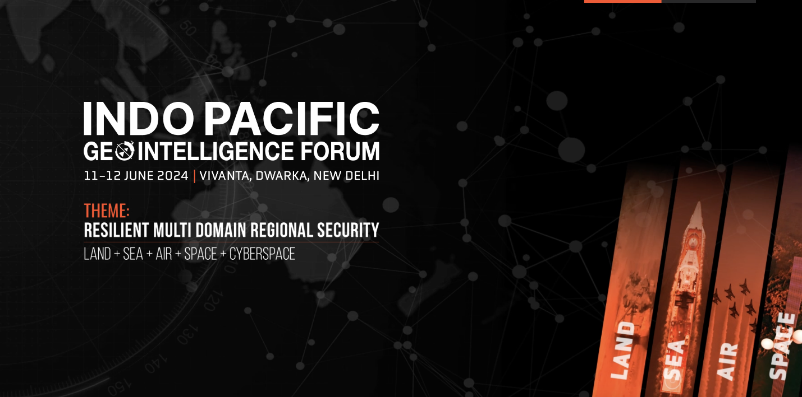

To know More: <https://geointelligence.net/2024/index.html#:~:text=Indo%2DPacific%20GeoIntelligence%20Forum%202024,India%20%7C%20A%20Geospatial%20Defence%20Conference>



To know more: <https://www.ipc.org/ipc-india/iemi-bengaluru-registration>

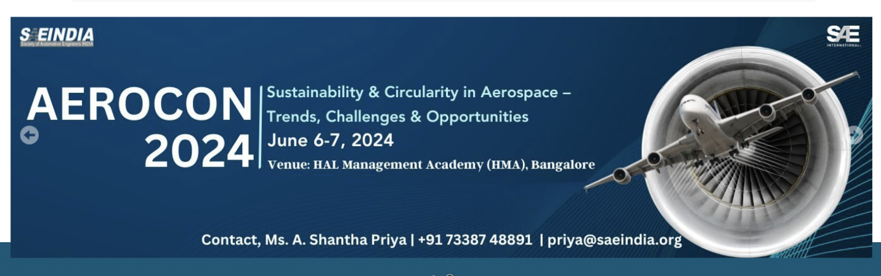To know more: <https://saeindia.org/aerocon2024/>